For 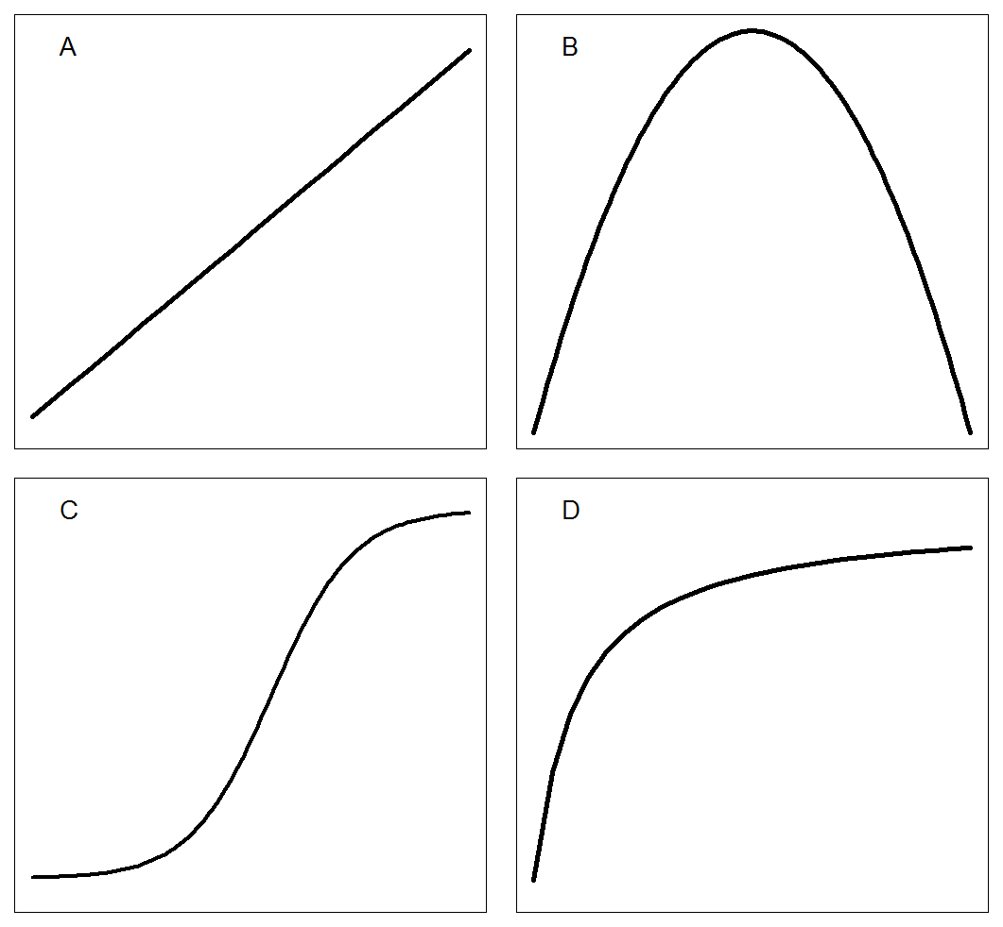Figure 1. Common regression curves used to describe the data from crop-weed competition studies in additive design: A) linear; B) polynomial quadratic; C) sigmoid (logistic model); D) rectangular hyperbola (Cousens model).



Figure 2. Relationship between corn biomass reduction (%) and weed density (plants pot-1) described with the rectangular hyperbola model. Red dotted and black solid lines represent *R. brasiliensis* and *C. benghalensis*, respectively



Figure 3. Relationship between maize biomass reduction (%) and weed density (plants pot-1) fitted with a logistic model. Red dotted lines represent *R. brasiliensis* and black solid line represents *C. benghalensis*.



Figure 4. The relationship between maize biomass reduction (%) and weed density (plants pot-1) fitted with a polynomial quadratic model. Red dotted lines represent *R. brasiliensis,* and the black solid line represents *C. benghalensis*.



Figure 5. The relationship between maize biomass reduction (%) and weed density (plants pot-1) fitted with rectangular hyperbola model. Red dotted lines represent *R. brasiliensis,* and the black solid line represents *C. benghalensis*.

Table 1. Corn yield loss (%) model comparison among polynomial quadratic, logistic, and Cousens.

|  |  |  |  |  |  |
| --- | --- | --- | --- | --- | --- |
| Models | Species | Model Selection1 | Goodness of Fit2 | | |
| AICc | RMSE | ME | R2 |
| Rectangular hyperbola | *C. benghalensis* | 332.2 | 12.6 | 0.92 | - |
|  | *R. brasiliensis* | 0.64 | - |
| Logistic | *C. benghalensis* | 337.6 | 13.2 | 0.85 | - |
|  | *R. brasiliensis* | 0.58 | - |
| Polynomial quadratic | *C. benghalensis* | 343.1 | 19.4 | 0.90 | 0.89 |
|  | *R. brasiliensis* | 0.71 | 0.71 |

1Alkeike’s information criterion (AIC).

2Root mean square error (RMSE), model efficiency (ME), and R-squared (R2). R2 is not appropriate for nonlinear models (logistic and Cousens)

Table 2. Cousens model parameters estimates, standard error, t-value and P-value of maize biomass reduction (%) caused by competition of *R. brasiliensis* and *C. benghalensis*.

|  |  |  |  |  |  |
| --- | --- | --- | --- | --- | --- |
| Parameters1 | Species | Estimate | Standard Error | t-value | P-value |
|  |  | % | |  |  |
| *I* | *R. brasiliensis* | 50.3 | 22.6 | 2.2 | 0.03 |
| *C. benghalensis* | 210.2 | 88.6 | 2.4 | 0.02 |
| *A* | *R. brasiliensis* | 82.1 | 23.1 | 3.6 | 0.00 |
| *C. benghalensis* | 108.6 | 11.1 | 9.7 | 0.00 |

1*I*: represents maize biomass reduction (%) per unit weed density as density approaches 0; *A*: represents maize biomass reduction (%) as density approaches ∞ (or maximum expected yield loss).

2If P<0.05, there is no lack of fit; If P>0.05, there is a lack of fit. *** Significant at <0.01.

Table 3. Logistic model parameters estimates, standard error, t-value and P-value of maize biomass reduction (%) caused by competition of *R. brasiliensis* and *C. benghalensis*.

|  |  |  |  |  |  |
| --- | --- | --- | --- | --- | --- |
| Parameters1 | Species | Estimate | Standard Error | t-value | *P*-value |
|  |  | % | |  |  |
| *b* | *R. brasiliensis* | -1.5 | 1.4 | -1.1 | 0.29 |
| *C. benghalensis* | -3.2 | 5.1 | -0.6 | 0.54 |
| *c* | *R. brasiliensis* | 0.2 | 7.4 | -<0.0 | 0.99 |
| *C. benghalensis* | -5.3 | 7.4 | -<0.0 | 0.98 |
| *d* | *R. brasiliensis* | 67.2 | 26.9 | 2.5 | 0.02 |
| *C. benghalensis* | 93.4 | 8.4 | 11.1 | 0.00 |
| *e* | *R. brasiliensis* | 1.2 | 0.7 | 1.6 | 0.12 |
| *C. benghalensis* | 0.7 | 0.3 | 2.1 | 0.04 |

1*b*: slope; *c*: lower limit (weed competition at low densities); d: upper limit (maximum expected maize biomass reduction, %); *e*: inflection point (weed density at maize biomass reduction is 50% relative to *d*.

2If P<0.05, there is no lack of fit; If P>0.05, there is a lack of fit. *** Significant at 0.01; * Significant at 0.1; NS, not significant.

Table 4. Polynomial quadratic parameters estimates, standard error, t-value and P-value of maize biomass reduction (%) caused by competition of *R. brasiliensis* and *C. benghalensis*.

|  |  |  |  |  |  |  |
| --- | --- | --- | --- | --- | --- | --- |
| Parameters1 | Species | Estimate | Standard Error | t-value | P-value | |
|  |  | % | |  |  |  |
| α | *R. brasiliensis* | -0.7 | 7.7 | -0.1 | 0.92 |  |
| *C. benghalensis* | 4.9 | 6.1 | 0.8 | 0.43 |  |
| a | *R. brasiliensis* | 35.5 | 9.1 | 3.8 | 0.00 |  |
| *C. benghalensis* | 65.5 | 7.3 | 9.0 | 0.00 |  |
| b | *R. brasiliensis* | -5.4 | 2.2 | -2.5 | 0.02 |  |
| *C. benghalensis* | -11.1 | 1.7 | -6.4 | 0.00 |  |

1α: intercept at Y-value when density equals zero; a is the slope of the equation; b is the quadratic term of the equation.

2If P<0.05, there is no lack of fit; If P>0.05, there is a lack of fit. *** Significant at 0.01; * Significant at 0.1; NS, not significant.

Table 5. Nested model selection criteria and goodness of fit of Cousens model parameters I and A of maize biomass reduction (%) with *R. brasiliensis* and *C. benghalensi*s.

|  |  |  |  |  |  |  |
| --- | --- | --- | --- | --- | --- | --- |
| Cousens Models | Species | Model Selection1 | | | Goodnes of fit2 | |
| F-test | | AICc | RSME | ME |
| F-value | P-value |
| Different I and A (Full) | *R. brasiliensis* | - | - | 332.2 | 13.3 | 0.92 |
| *C. benghalensis* | 0.64 |
| Similar I and A (Red. I) | *R. brasiliensis* | 32.3 | 0.00 | 368.2 | 22.2 | 0.84 |
| *C. benghalensis* |
| Similar I but different A (Red. II) | *R. brasiliensis* | 4.1 | 0.04 | 333.9 | 14.0 | 0.97 |
| *C. benghalensis* | 0.69 |
| Similar A but different I (Red. III) | *R. brasiliensis* | 0.7 | 0.40 | 330.4 | 13.4 | 0.98 |
| *C. benghalensis* | 0.95 |

1F-test model selection; P<0.05: significant different models; P>0.05: non-significant different models. Alkeike’s information criterion (AIC);

2Root mean square error (RMSE) and model efficiency (ME).

Table 6. Cousens model parameters estimates, standard error, t-value and P-value of corn yield loss (%) caused by competition of *R. brasiliensis* and *C. benghalensis*.

|  |  |  |  |  |  |  |  |
| --- | --- | --- | --- | --- | --- | --- | --- |
| Parameters1 | Species | Estimate | Standard Error | t-value | | P-value | |
|  |  | % | | |  | |  |
| I | *R. brasiliensis* | 37.0 | 6.2 | | 5.9 | | 0.00 |
| *C. benghalensis* | 228.3 | 100.2 | | 2.3 | | 0.03 |
| A | *R. brasiliensis* | 106.1 | 10.3 | | 10.3 | | 0.00 |
| *C. benghalensis* |

1 *I*: represents maize biomass reduction (%) per unit weed density as density approaches 0; *A*: represents maize biomass reduction (%) as density approaches ∞ (or maximum expected yield loss).

2If P<0.05, there is no lack of fit; If P>0.05, there is a lack of fit. *** Significant at <0.01.